

**Our journey to embedding energy management “insert COMPANY”**

**Embedding Energy Management (EEM) Plan**

**DD/MM/YYYY**

|  |
| --- |
| Description: logo_and_text |
| The material provided in this document has been produced in conjunction with our partner [Energetics Pty Ltd](http://www.energetics.com.au/). |

This publication was funded by the Australian Government through the Workforce Innovation Program under the title 'Carbonproof for Foundries'.

**Embedding Energy Management (EEM) is available from** **www.sustainabilityskills.net.au**

|  |  |
| --- | --- |
|  | **Free for Education Copying**  [www.mskills.com.au](http://www.mskills.com.au) |

This work is copyright and licensed under the MSA Free for Education Copying instant licence (MSA Licence).

When you obtain a copy of material that bears the MSA licence mark by legitimate means you obtain an automatic licence to use and copy the work in whole or in part, solely for educational purposes.

**Individual learners may:**

1. use the material personally for their education such as including it, with proper attribution, in work that is performed in the course of that education; and
2. make unlimited copies, in whole or in part, of the material.

**Education Providers or Other Organisations may:**

1. use the material within the organisation or for the services provided by the organisation;
2. make or give copies to learners;
3. charge for the education provided; and
4. charge learners for the material on a cost-recovery basis.

Queries regarding the MSA Licence conditions should be directed through the MSA website at [www.mskills.com.au](http://www.mskills.com.au)

In addition to the standard MSA Licence conditions, the following **special conditions** apply:

1. Territory: The copyright work must only be used in Australia and New Zealand.
2. Development Rights: Licensees are permitted to develop either an Edited Version or Enhancements of the Licensed Material for individual organisation purposes.

**Disclaimer**

This work is the result of wide consultations with Australian industry participants. It is a collaborative view and does not necessarily represent the view of MSA or any specific body. For the sake of conciseness it may omit factors which could be pertinent in particular cases.

While care has been taken in the preparation of this resource, MSA and the original developer do not warrant that any licensing or registration requirements specified here are either complete or up-to-date for your State or Territory. MSA and the original developer does not accept any liability for any damage or loss (including indirect and consequential loss) incurred by any person as a result of relying on the information contained in this training resource.

This work is in response to the intent of the unit of competency from the respective Training Package but must be customised and contextualised to meet the end user requirements as it may not be fully compliant in its current format. The material is provided on this basis to any person for information and advice for the intended purpose and all persons accessing this material undertake responsibility for assessing the relevance and accuracy of its content. No liability is accepted for any information or services which may appear in any other format. No responsibility is taken for any information or services which may appear on any linked websites.

Published by:

|  |  |
| --- | --- |
| Manufacturing Skills Australia  Level 3, 104 Mount Street  North Sydney NSW 2060  ABN:88 006 441 685  Phone: (02) 9955 5500  Fax: (02) 9955 8044  Website: <http://www.mskills.com.au>  First published: 2013 |  |

Contents

[1 The strategic intent for energy and carbon management at “COMPANY” 2](#_Toc359329370)

[1.1 Improvement goals 3](#_Toc359329371)

[1.2 COMPANY’s sustainability vision 3](#_Toc359329372)

[1.3 Sustainability policies to drive strategic intent 4](#_Toc359329373)

[2 Carbon inventory and supply chain action plan for COMPANY 6](#_Toc359329374)

[2.1 The purpose of this plan 6](#_Toc359329375)

[2.2 Energy and Ccarbon emissions baseline 6](#_Toc359329376)

[2.3 Carbon economy and other global trends: risks and opportunities 6](#_Toc359329377)

[2.4 Carbon inventory and supply chain improvement goals 7](#_Toc359329378)

[2.5 Sustainability policies relating to carbon management 7](#_Toc359329379)

[2.6 Carbon management systems 8](#_Toc359329380)

[2.7 Action plan to implement carbon plan (policies and guidelines) 9](#_Toc359329381)

[3 Energy efficiency management plan (including procurement opportunities) 10](#_Toc359329382)

[3.1 The purpose of this plan 10](#_Toc359329383)

[3.2 Energy use baseline and priority opportunities 10](#_Toc359329384)

[3.3 Energy use goals 11](#_Toc359329385)

[3.4 Energy use policies (selected from new sustainability policies) 11](#_Toc359329386)

[3.5 Energy management systems 12](#_Toc359329387)

[3.6 List of priority energy efficiency opportunities 12](#_Toc359329388)

[4 Management systems improvement plan 13](#_Toc359329389)

[4.1 The purpose of this plan 13](#_Toc359329390)

[4.2 Related policies and guidelines 13](#_Toc359329391)

[4.3 Management systems that require improvements 14](#_Toc359329392)

[5 Workforce development plan 15](#_Toc359329393)

[5.1 Skills matrix for the SLT 15](#_Toc359329394)

Project details

| COMPANY Contacts |
| --- |
| CEO  Site champion |

| Description | Prepared by | Reviewed by | Approved by | Approval date |
| --- | --- | --- | --- | --- |
| Version 1 |  |  |  |  |

# The strategic intent for energy and carbon management at “COMPANY”

“COMPANY” has developed a strategic response to the carbon economy and the associated cost increases in energy. Costs are expected to rise by XX-XX% over the next 3–5 years. For “COMPANY” the rise could be from $XXX,000 in YYYY to almost $ZZZ,000 in YYYY. Given these substantial increases, it is imperative that the impact of these price rises is minimised, in line with “COMPANY’S” profit goals.

Customers, industry, the community at large and different levels of government are demanding:

* greater transparency in reporting carbon emissions
* more efficient use of energy.

The “COMPANY” board of directors is also demanding an increase in profit margins.

“COMPANY” is beginning to meet these challenges. However, there is considerable work to be done to better understand current energy performance within the business, and the opportunities for carbon mitigation and cost savings. This work will be ongoing in order to ensure that “COMPANY” can demonstrate its green credentials to our customers, community and regulators as required.

As a result of utilising the Embedding Energy Management (EEM) program, “COMPANY’s” current status in the sustainability journey has been determined, and appropriate management plans have been prepared. On commencement of the program the site leadership team (SLT) reviewed the maturity of the business using the sustainability business model illustrated in Figure 1 and identified our current status as:

* ‘Aware’ of energy efficiency opportunities
* ‘Aware’ of consumer demands for carbon emissions reporting.



Figure 1 - Business sustainability maturity curve

## Improvement goals

COMPANY aims to become’Proactive’ in energy efficiency and carbon management and industry leadership.

The following improvement goals were created during the EEM program:

* The Board will be provided with information about the potential for energy cost savings in order to develop the confidence to invest in new technologies.
* COMPANY’s customers will be informed of improvements in emissions levels in order to consider their own marketing opportunities.
* Energy usage will be measured to identify savings opportunities.
* Energy costs per unit of production will be reduced to improve profit margins.

As a result of the EEM program**,** COMPANY hasbegun to demonstrate a proactive response to energy cost and efficiency as outlined in Table 1.

Table 1 - Actioned Initiatives, MONTH YYYY

| Opportunity | Saving |
| --- | --- |
| Opportunity # 1 | $xx,000 |
| Opportunity # 2 | $xx,000 |
| Opportunity # 3 | $xx,000 |

A total of XX energy saving opportunities have been identified of which X priority opportunities are currently under investigation (See Appendices for full list. See page XX for top 4 opportunities).

These improvement goals will be progressed in line with COMPANY’s business plans, including plans to:

* increase volume
* increase profit
* establish additional shifts
* build additional capacity
* enhance supporting systems.

## COMPANY’s sustainability vision

**Our vision is to be a step ahead of our competitors in sustainability, as demonstrated by innovative practices in energy efficiency and carbon mitigation.**

As a business, COMPANY recognises the biophysical limits of the ecosystem as described in Figure 2, and the contribution made to the stressors that exist within the environment. At a local level COMPANY understands the contribution the business makes to commerce, employment and skills development in the community.

Biophysical limits

**The ecosystem**

**Society**

**Technology**

Encroachment

on biophysical

limits

**Anthropogenic**

**stressors**

•

Population

Increases

•

Urbanisation

increases

**Water**

**systems**

**Energy**

**systems**

***Service***

***provision /***

***product***

**Interaction**

between water,

energy and

waste systems

**Environmental**

**stressors**

•

Climate change

•

Resource use

•

Land use

**Waste**

**systems**

Figure 2 - Eco system model

## Sustainability policies to drive strategic intent

These policies were created by the SLT during the EEM program after a presentation on global trends in resource management and consideration of existing business plans.

* **Policy No 1**   
  Leverage trends in sustainability to enhance our major customers and suppliers sustainability performance through improved collaboration and transparency in carbon reporting.
* **Policy No 2**   
  Reduce energy costs and invest savings in innovation and improved productivity using broad business case criteria and government funding, where available.
* **Policy No 3**   
  Adapt our continuous improvement approach to include energy savings opportunities that don’t involve significant capital investment.
* **Policy No 4**   
  Initiate new markets that will pay for our quality sustainability attributes.
* **Policy No 5**   
  Exploit the sustainability talents of the SLT to improve the COMPANY operations and the long-term viability of these operations.
* **Policy No 6**   
  Continually benchmark management systems to support our sustainability goals.

The policies and guidelines are being implemented via a series of pragmatic initiatives detailed in the following plans.

* Carbon inventory and supply chain plan
* Energy procurement improvement plan
* Energy efficiency plan
* Management systems improvement plan.

These plans will be reviewed at the SLT weekly meetings. The subsequent projects will be reported at weekly SLT meetings and continuous improvement meetings.

# Carbon inventory and supply chain action plan for COMPANY

## The purpose of this plan

This plan has been developed by the SLT during the EEM program to manage the risks and opportunities arising from the carbon economy in view of COMPANY carbon inventory and current business plans.

## Energy and Ccarbon emissions baseline

Total energy and associated emissions and costs for the site are illustrated in Figure 2.

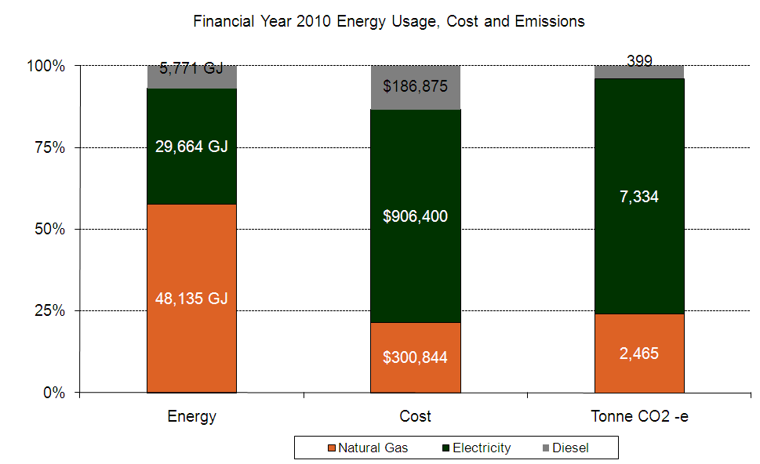

Figure 2 - COMPANY energy, emissions and cost profile

The priority opportunity for carbon mitigation is the replacement of the site’s electric steam boiler with a gas hot water and small gas-fired steam boiler. A reduction of X,XXX tCO2-e would result, which represents XX% for the site’s greenhouse gas emissions.

A full carbon inventory for scope 1 and 2 emissions is available in the Appendices.

## Carbon economy and other global trends: risks and opportunities

The following risks and opportunities were identified by the SLT as part of the carbon inventory and supply chain module of the EEM program (day 2).

**Risks**

* Cost of energy will rise, reducing the site’s profit margin.
* Suppliers ‘passing’ through costs associated with carbon accounting and energy price rises.
* More competitive pricing from overseas competitors.
* Cost of future regulations and compliance.
* Inability to supply data requests making our products less attractive to customers.
* Local competitors being able to report on carbon emissions reductions ahead of COMPANY.

**Opportunities**

* COMPANY can strengthen customer and supplier relationships via collaboration on carbon labelling and carbon footprinting activities.
* Product innovation and local sourcing.
* Rigour in reporting carbon may assist the development of a business case for efficiency opportunities.
* Environment key performance indicators (KPIs) could be launched within the business and monitored to assist with profit goals.
* Use continuous improvement to progress opportunities.
* COMPANY can be the leader in carbon reporting within its industry sub-sector.

## Carbon inventory and supply chain improvement goals

As stated earlier, it is anticipated that COMPANY’s customers will increasingly demand carbon-related data. COMPANY intends to be proactive in undertaking dialogue with both customers and suppliers.

The SLT considers COMPANY’s current focus on managing carbon emissions is based on cost considerations and compliance requirements, having now moved from a basic awareness level. Now that a Carbon inventory (Scope 1 & 2) has been established, these issues can be considered from an informed position.

**The goal for carbon management at COMPANY** **is to inform our customers of our emissions and exploit marketing opportunities.**

## Sustainability policies relating to carbon management

A series of short forums were conducted to inform the team of the carbon related business trends affecting the business and to facilitate a response from the leadership team. Policy statements were created and guidelines were developed to guide the team to address these questions. Several questions are yet to be addressed and will be progressed at regular SLT meetings.

**Sustainability Policy No 1: Leverage trends in sustainability to enhance our major customers’ sustainability performance through improved collaboration with our customers and suppliers.**

* Strategic question: How can trends in carbon and energy management be leveraged to encourage customers to work with COMPANY to make operational changes that are mutually beneficial?
* Strategic question: What opportunity is there to contribute to improving the sustainability performance metrics of customers, in keeping with planned improvements to COMPANY’s products and operating practices?
* Policy guideline 1.1: Tools should be introduced to capture data immediately to understand COMPANY’s carbon position, before initiating contact with suppliers and customers.
* Policy guidelin 1:2: Customers should be approached to identify opportunities to standardise packaging in the context of carbon management and COMPANY’s packaging covenant.

**Sustainability Policy No 4: Initiate new markets that will pay for our quality sustainability attributes.**

* Strategic question: How can a market for COMPANY’s products be identified that will pay for the quality attributes?
* Strategic question: What advantages are there to becoming compliant or a leader in ethical sourcing and/or better traceability?

## Carbon management systems

A management systems diagnostic was completed as part of the program. The following management systems were identified as needing enhancements to meet the agreed carbon inventory and supply chain goals.

* Customer communications system – requests to suppliers for emissions data and offering data to customers (based on scope 1 & 2 carbon inventory).
* Quality assurance (QA) – integrate energy and carbon reporting into the QA system.
* Production reporting – develop and report energy performance indicators per unit production (KPIs).

An improvement brief has been created by the SLT for each system and delegated to the manager responsible for each system. See management systems improvement plan (below) for details.

## Action plan to implement carbon plan (policies and guidelines)

After a series of workshops during the EEM program the following actions to initiate implementation of carbon management policies were identified.

| Policy Guideline | Action | Responsible person | With | By when |
| --- | --- | --- | --- | --- |
| Policy guideline 1.1: | Integrate energy and carbon tools into QA auditing systems |  |  |  |
|  | *Task 1:Develop greenhouse information system, including carbon inventory system and submit this to SLT for approval* | NAME 1 | NAME 2 | DD/MM/YY |
|  | *Task 2:Capture monthly runtime product/line* | NAME 2 | NAME 4 | DD/MM/YY |
|  | *Task 3:Write procedures for...* | NAME 3 | NAME 1 | DD/MM/YY |
|  | *Task4: Conduct training on XYZ tools* | NAME 4 | NAME 3 | DD/MM/YY |

# Energy efficiency management plan (including procurement opportunities)

## The purpose of this plan

This plan has been developed by the SLT during the EEM program to identify and progress energy savings consistent with COMPANY strategic intent for sustainability and current business plans.

## Energy use baseline and priority opportunities

Total energy use for the site is illustrated in Figure 3. A break-up of the resource costs by plant at the COMPANY site is provided in Figure 4. These figures are available in the **Energy baseline**.

With the exception of collecting energy data at a basic level there has been no specific energy savings initiatives progressed at the COMPANY site.

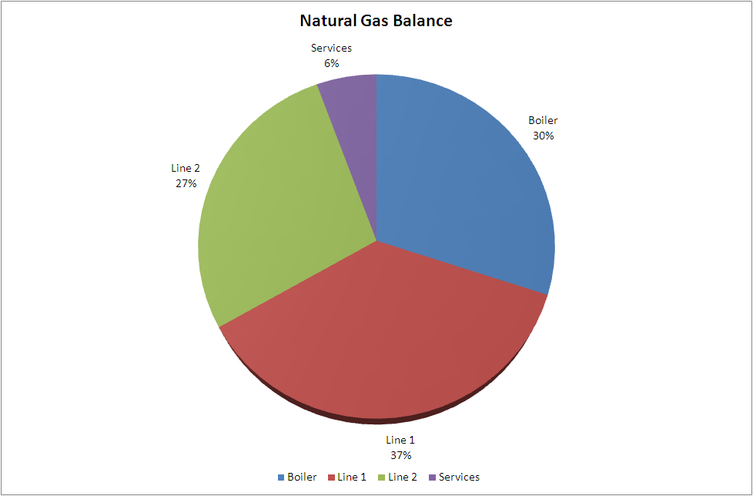

**Figure 3 – Total energy use**

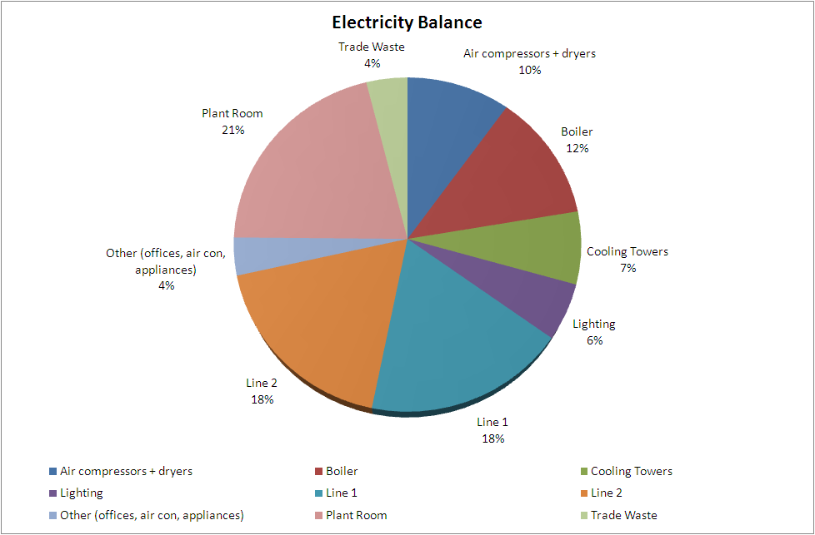

Figure 4 - Resource split by energy form/plant area

The priority opportunities for energy savings are:

* Change from a standard natural gas tariff to a discounted tariff with annual savings of $XX,000 and almost instant payback.
* Repair of the EQUIPMENT with annual savings of $XX,000 and an IRR of XXX%.
* Replacement of the electric steam boiler with a gas hot water boiler and small gas-fired steam boiler, with annual potential savings of $XXX,000 and an IRR of XX%.
* Replacement of EQUIPMENT with NEW EQUIPMENT with potential annual savings in excess of $XXX,000 and an IRR in excess of XX%.

A full list of opportunities with ranking and other information is available in project list in the **Energy efficiency opportunities workbook**.

## Energy use goals

The SLT considers the site’s current focus for energy management is on cost reduction and compliance.

The goals for energy use at COMPANY are to:

* measure energy end use to identify savings opportunities
* reduce energy costs per unit of production to improve profit margins using CAPEX criteria which demands a 5% reduction in energy costs with a two year payback.

## Energy use policies (selected from new sustainability policies)

A series of short forums were conducted to inform the team of the global trends affecting the business and to facilitate a response from the leadership team. After presenting the global trends in resource management affecting our industry sector a series of strategic questions about energy use were raised by the SLT. Policy statements were created and guidelines were developed to guide the team to address these questions. Several questions are yet to be addressed and will be progressed at regular SLT meetings. An opportunities screening workshop was conducted to inform the team of the energy use baseline, including existing and new efficiency opportunities, and to decide which opportunities should be given priority.

**Sustainability Policy No 2: Reduce energy costs and invest savings in innovation and improved productivity**

* Strategic question: How can energy costs be reduced?
* Policy guideline: The profitability of these cost saving initiatives should be demonstrated in order to invest in innovation and improve overall productivity.
* Policy guideline: Through data collection and the appropriate skills to manage carbon emissions, energy and emissions savings opportunities can be factored into operating decisions, e.g. peak demand and load shifting.
* Policy guideline: The potential cost of carbon in our resource efficiency projects should be included to demonstrate carbon reduction plans and support business cases.

## Energy management systems

A management systems diagnostic was completed as part of the EEM program. The following management systems were identified as needing enhancements to meet the resource efficiency goals of the business.

* Production reporting – developing and reporting energy performance indicators per unit of production (KPIs).
* Training system – induction system to be revised to reflect new policies. A new toolbox series to be created to roll out the new policies and increase staff awareness.

An improvement brief has been created by the SLT for each system and delegated to the manager responsible for each system. See management systems improvement plans (briefs) in Appendix.

## List of priority energy efficiency opportunities

The SLT developed a list of XX energy efficiency opportunities that were discussed and prioritised against COMPANY resource management goals. The top X strategic and X quick win opportunities are provided in Table 2.

Table 2. High priority resource opportunities

| Opportunity | Type | Rating | Champion | Approval Status |
| --- | --- | --- | --- | --- |
| OPPORTUNITY # 1 | Technology | Strategic |  |  |
| OPPORTUNITY # 2 | Process optimisation | Strategic |  |  |
| OPPORTUNITY # 3 | Behavioural change | Operational |  |  |
| OPPORTUNITY # 4 | Operational | Operational |  |  |

# Management systems improvement plan

## The purpose of this plan

The savings from resource efficiency initiatives can be optimised when management systems support the implementation and maintenance of these initiatives. This plan was created during the EEM program. A management system diagnostic was used to identify critical actions necessary to improve COMPANY’s management systems so that the cost saving and carbon reporting initiatives continue to be effective over time, rather than being a one-off event.

## Related policies and guidelines

**Sustainability Policy No 6: Benchmark our management systems to support our sustainability goals**

* Action plan: Raise these issues at SLT meetings in the context of existing project plans and consider a repeat of the diagnostic used in this program to report improvements to the Board.

**Sustainability Policy No 3: Adapt our continuous improvement approach to include energy savings opportunities that don’t involve significant capital investment (e.g. shutdown procedures and load shifting procedures)**

* Strategic question: How can production processes be improved to reduce energy usage without the capital to purchase more efficient technology?
* Policy guideline: A continuous improvement process for carbon and energy initiatives should be initiated so that behavioural and other low-cost incremental improvements can be progressed.
* Policy guideline: Energy use trends should be documented so that reporting can be updated to monitor trends and inform management decisions.
* Action plan: Raise these issues at SLT meetings in the context of existing project plans.

**Sustainability Policy No 5: Exploit the sustainability talents of the SLT to improve the site’s operations and the long-term viability of these operations.**

* Strategic question: How can COMPANY operations be improved so as to ensure the long-term viability of those operations?
* Policy guideline: Better management of carbon and energy reporting is needed, so that the leadership team can make informed resource use improvement decisions.
* Policy guideline: We need to project manage employees and their time to reduce carbon emissions. The practices that achieve these emissions reductions should be documented and consistently applied to improve business outcomes.
* Action plan: Raise these issues at SLT meetings in the context of existing project plans.

## Management systems that require improvements

The individual action plans that have been created for each of the system improvements are available in the XXXX.

* Energy KPIs: KPI sto be integrated into production reporting system so that targets can be determined and improvements reported.
* Carbon reporting: Carbon inventory to be integrated into resource use reporting system so that SLT can initiate reporting with key suppliers and key customers.
* Carbon information management system: Carbon management to be integrated into QA system.
* Energy procurement: Energy market information to be made available to SLT for energy procurement decisions.
* Staff awareness: Energy/carbon toolbox sessions to be added to the training system to increase staff awareness and participation.
* Accountability for resource use: Responsibility for energy KPIs carbon reporting and execution of these plans to be integrated into job descriptions.

# Workforce development plan

## Skills matrix for the SLT

The purpose of this plan is to expose the current status of the leadership team’s development in ‘green skills’ so that they can continue their own up-skilling to support the roll out of the sustainability plans. This compares perceived level of understanding and importance attached to each element of the five EEM good practice modules BEFORE and AFTER EEM, as assessed by the participants.

| SLT training participant | Module | Skill sets / attached importance (low=1, 4=high) | | | | Comment | Evidence of skills applied |
| --- | --- | --- | --- | --- | --- | --- | --- |
|  |  | Rating before | | Rating after | |  |  |
| NAME, POSITION | M1 Energy and business planning | | | | | | |
| Develop a high-level understanding of energy use, carbon emissions and major business inputs as input to evaluation of the global trends | Low  (level) | 2  (importance) | High | 4 |  |  |
| Inform business planning of the business drivers for better energy and carbon management | Medium | 3 | High | 4 |  |
| Communicate business drivers and engage site operations and management to identify high-level plans | High | 2 | High | 3 |  |
| Recognise high-level opportunities and risks to be integrated into plans (that require further investigation) | Low | 3 | Medium | 4 |  |
| Facilitate integration of strategic priorities to business plans | High | 2 | High | 3 |  |
| Monitor and investigate performance against plans and communicate outcomes | High | 2 | High | 3 |  |
| NAME, POSITION | M2 Carbon inventory and supply chain impacts | | | | | | |
| Inform business planning using high-level carbon data and relevant contextual information | High | 2 | High | 3 |  |  |
| Communicate and investigate with engaged stakeholders to develop carbon inventories and reports | High | 3 | High | 3 |  |
| Use carbon inventories and report to better understand energy use | High | 3 | High | 3 |  |
| Identify opportunities and risks within the supply chain | High | 2 | High | 3 |  |
| Facilitate implementation of carbon planning outcomes | High | 2 | High | 3 |  |
| Monitor and investigate progress of plans | Low | 4 | Medium | 3 |  |
| NAME, POSITION | M3 Energy procurement | | | | | | |
| Understand energy use and calculate current cost impacts | High | 1 | High | 2 |  |  |
| Use energy market and price trends to inform business planning of future costs | High | 2 | High | 3 |  |
| Explore and identify opportunities to reduce energy costs | High | 2 | High | 3 |  |
| Investigate contract options and communicate energy market intelligence with engaged stakeholders | High | 2 | High | 3 |  |
| Facilitate implementation of cost reduction opportunities | High | 2 | High | 3 |  |
| Monitor and investigate implementation of novel procurement practices to explore changes in the market | Low | 2 | Medium | 3 |  |
| NAME, POSITION | M4 Energy Efficiency Opportunities | | | | | | |
| Inform business planning of energy efficiency opportunities | Medium | 3 | High | 3 |  |  |
| Communicate and investigate energy efficiency opportunities with engaged stakeholders | Medium | 3 | High | 3 |  |
| Understand energy use and management | Medium | 3 | High | 4 |  |
| Identify and evaluate energy efficiency opportunities | High | 2 | High | 3 |  |
| Facilitate implementation of efficiency opportunities | High | 3 | High | 3 |  |
| Measurement and verification of energy efficiency opportunities | Medium | 3 | High | 3 |  |
| NAME, POSITION | M5 Energy management systems | | | | | | |
| Inform business planning of a systems approach to resource efficiency to support energy plans (strategic intent) | High | 3 | High | 3 |  |  |
| Communicate and investigate gaps in management systems with engaged stakeholders | High | 3 | High | 3 |  |
| Design improvements to management systems necessary to improve understanding of resource use across the business | High | 3 | High | 4 |  |
| Design improvements to management systems necessary to systematically identify new, and sustain existing energy efficiency opportunities | High | 3 | High | 4 |  |
| Facilitate implementation of improvements to management and monitoring systems | High | 3 | High | 3 |  |
| Monitor and investigate and report outcomes of enhancements to management systems | High | 3 | High | 3 |  |

Appendices

| Title | Description | Document |
| --- | --- | --- |
| Project tracking list | COMPANY Projects tracking list |  |
| Baseline | Energy break-up of COMPANY  Material used in the resource efficiency module |  |
| Carbon inventory | Contains details of the site carbon emissions |  |
| Energy KPI | KPI to be integrated into production reporting system – Project improvement plan (brief) |  |
| Carbon reporting | Carbon inventory to be integrated into resource use reporting system – Project improvement plan (brief) |  |
| Carbon information management system | Carbon management to be integrated into Quality Assurance system – Project improvement plan (brief) |  |
| Energy procurement | Energy market information to be made available to SLT for energy procurement decisions – Project improvement plan (brief) |  |
| Staff awareness | Energy/carbon toolbox sessions to be added to the training system to increase staff awareness and participation – Project plan (brief) |  |
| Accountability for resource use | Responsibility for energy KPIs carbon reporting and execution of plans to be integrated into job descriptions – Project plan (brief) |  |