

**Embedding Energy Management (EEM)**

**Facilitator runsheet - Module 2: Carbon inventory and supply chain impacts**

|  |  |
| --- | --- |
| The material provided in this guide has been produced in conjunction with our partner [Energetics Pty Ltd](http://www.energetics.com.au/). | Description: logo_and_text |

This publication was funded by the Australian Government

through the Workforce Innovation Program under the title 'Carbonproof for Foundries'.

**Embedding Energy Management (EEM) is available from** **www.sustainabilityskills.net.au**

|  |  |
| --- | --- |
|  | **Free for Education Copying**  [www.mskills.com.au](http://www.mskills.com.au) |

This work is copyright and licensed under the MSA Free for Education Copying instant licence (MSA Licence).

When you obtain a copy of material that bears the MSA licence mark by legitimate means you obtain an automatic licence to use and copy the work in whole or in part, solely for educational purposes.

**Individual learners may:**

1. use the material personally for their education such as including it, with proper attribution, in work that is performed in the course of that education; and
2. make unlimited copies, in whole or in part, of the material.

**Education Providers or Other Organisations may:**

1. use the material within the organisation or for the services provided by the organisation;
2. make or give copies to learners;
3. charge for the education provided; and
4. charge learners for the material on a cost-recovery basis.

Queries regarding the MSA Licence conditions should be directed through the MSA website at [www.mskills.com.au](http://www.mskills.com.au)

In addition to the standard MSA Licence conditions, the following **special conditions** apply:

1. Territory: The copyright work must only be used in Australia and New Zealand.
2. Development Rights: Licensees are permitted to develop either an Edited Version or Enhancements of the Licensed Material for individual organisation purposes.

**Disclaimer**

This work is the result of wide consultations with Australian industry participants. It is a collaborative view and does not necessarily represent the view of MSA or any specific body. For the sake of conciseness it may omit factors which could be pertinent in particular cases.

While care has been taken in the preparation of this resource, MSA and the original developer do not warrant that any licensing or registration requirements specified here are either complete or up-to-date for your State or Territory. MSA and the original developer does not accept any liability for any damage or loss (including indirect and consequential loss) incurred by any person as a result of relying on the information contained in this training resource.

This work is in response to the intent of the unit of competency from the respective Training Package but must be customised and contextualised to meet the end user requirements as it may not be fully compliant in its current format. The material is provided on this basis to any person for information and advice for the intended purpose and all persons accessing this material undertake responsibility for assessing the relevance and accuracy of its content. No liability is accepted for any information or services which may appear in any other format. No responsibility is taken for any information or services which may appear on any linked websites.

Published by:

|  |  |
| --- | --- |
| Manufacturing Skills Australia  Level 3, 104 Mount Street  North Sydney NSW 2060  ABN:88 006 441 685  Phone: (02) 9955 5500  Fax: (02) 9955 8044  Website: <http://www.mskills.com.au>  First published: 2013 |  |

CONTENTS

[Purpose of a facilitator runsheet 1](#_Toc359332242)

[Sample agenda for the program 2](#_Toc359332243)

[Planning forum 2: Carbon inventory and supply chain impacts 3](#_Toc359332244)

[The *communication marketplace* methodology 5](#_Toc359332245)

# Purpose of a facilitator runsheet

A facilitator runsheet is provided for each module in the Embedding Energy Management (EEM) program.The runsheets provide a guide for the facilitator so that they can prepare and deliver a business planning session that maximises the engagement of the Site Leadership Team (SLT). The facilitated forums capture the managers intelligence about the issues and ultimately informs a collaborative decision-making approach to this work. The processes described in these runsheets support a multidisciplinary approach, often reported as a hurdle for energy and sustainability initiatives, to be applied to this important business improvement work.

It is recommended that a member of the SLT, not necessarily ‘the boss’ with the most refined facilitation skills, adopts the role of facilitator. Otherwise, an external facilitator could be contracted for this role.

The runsheets are structured as follows:

1. The project question that this forum is attempting to resolve. *Using a question rather than a title motivates a response.*
2. What are the outcomes the site is seeking from this work? *Important to start the session with the end in mind.*
3. What is the context? *Important for focussing the discussion and drawing on relevant information.*
4. Phase of the work? *Acknowledges that the work may be ongoing.*
5. When is the forum?
6. Purpose of the forum? *This forum may only progress the desired outcomes (Q2) to a particular stage.*
7. Who should be there – names/titles? *The right people must be present or else quality will suffer.*
8. What challenges/hurdles will we need to keep in mind with this group? *Acknowledges dynamics of the group that need to be managed.*
9. What are the working steps, i.e. questions that need to be discussed during this forum to achieve the stated purpose? *This is the key to the forum. Includes the information/analysis/data to be presented and the questions that will be discussed to achieve the purpose of the forum (Q6).*
10. What information do we have to present to stimulate thinking? *Highlights the preparation that must be undertaken and the information to be made available for the forum to be a success.*

# Sample agenda for the program

The following agenda is an outline of the sessions to conduct on-site to achieve learning and business outcomes OR in simulated environment to achieve learning outcomes only. The global trends planning session on the first day is critical and will influence the remaining activities on the other days. This agenda is offered in the suggested sequence; however, there may be sound reasons why you would change the sequence. As long as others follow that logic then modify as you see fit. Another critical consideration is the identification of appropriate individuals to attend training. It is recommended that at least two individuals be nominated to participate in each action learning (training) module.

| Suggested timing | Day 1 | Day2 | Day3 | Day 4 | Day 5 |
| --- | --- | --- | --- | --- | --- |
| 08:00–12.00 | Energy and business planning  Present global/ regional trends; discuss/plan response  Present high-level energy and carbon baseline, begin to recognise quick wins  (3.5 hr planning forum with SLT, with 30 minute break) | Carbon inventory and supply chain impacts  Present carbon inventory/ footprint; identify impacts on supply chain  (3.5 hr planning forum with SLT, with 30 minute break) | Energy procurement  Investigate potential cost savings via demand management and contract reviews  (3.5 hr planning forum with SLT, with 30 minute break) | Energy efficiency opportunities  Understand energy use  Identify, evaluate and facilitate implementation of resource efficiency opportunities (technical or management) (inc supply chain)  (3.5 hr planning forum with SLT, with 30 minute break) | Energy management systems  Expose gaps in management systems using diagnostic  Identify and implement enhancements to management systems  Monitor and report progress of plans  (3.5 hr planning forum with SLT, with 30 minute break) |
| 12:00-14:00 | Data gathering and investigation | Data gathering and investigation | Data gathering and investigation | Data gathering and investigation | Data gathering and investigation |
| 14:00–15:30 | M1: Training with champions  How to integrate global trends in resource management into your business planning process | M2: Training with champions  How to create and maintain your carbon inventory | M3: Training with champions  How to review your tariff and potentially reduce your energy bills | M4: Training with champions  How to engage staff and the SLT in decision-making processes to progress resource efficiency opportunities that make good business sense | M5: Training with champions  Workforce development skills matrix: Assessment of carbon proofing skills  Ongoing development plan |
| Ongoing | Data gathering and investigation | Data gathering and investigation | Data gathering and investigation | Data gathering and investigation | Data gathering and investigation |

# Planning forum 2: Carbon inventory and supply chain impacts

| Forum design aspect | Description |
| --- | --- |
| The project question that this forum is attempting to resolve.  What are the outcomes the site is seeking from this work? | What carbon-based sustainability initiatives should we initiate with our suppliers, customers and our own operations to add value to our products?  Ability to maintain documentation around our carbon inventory so that the SLT can provide useful footprint information to customers and make informed decisions on carbon-related business decisions. |
| What is the context?  Phase of development? | This project is designed so that users can apply a set of practice guides and tools and action learning modules to support the development of their workforce to meet the challenges of a carbon constrained economy.  It is day 2 of a 5-day program. |
| When is the forum? | As scheduled. |
| Purpose of the forum? | To reflect on our current carbon inventory (Scope 1 and 2 emissions) and the current status of the carbon economy so that we can:   1. Identify risks and opportunities emerging for the industry and this business (site). 2. Develop a plan to manage risks and opportunities (including supply chain interventions). 3. Identify actions to refine and maintain our carbon inventory and carbon management plan. |
| Who should be there names/titles? | SLT and staff with supply chain, customer and/or environmental management responsibility. |
| What challenges/hurdles will we need to keep in mind with this group? | Engaging with customers and suppliers in relation to your intent around carbon footprints/sustainability performance will call for a very proactive approach, engagement at new levels with customer and supplier organisations and perhaps sharing of plans relating to your efforts to meet their sustainability objectives. To do this, there must be a high level of accuracy and confidence in your carbon footprint and clarity around your footprint boundaries. |

| Forum design aspect | Description |
| --- | --- |
| What are the thinking steps (questions that need to be discussed) to achieve the stated purpose? | ***Present the carbon inventory presentation using a communication marketplace OR traditional PowerPoint (20 mins). Based on this, discuss***:   1. What do we understand about carbon emmissions and carbon reporting in our supply chain? *Input/output demonstration* (20 mins) 2. What are our current goals/business plans that are affected by a price on carbon? *Refer to communications marketplace* (2 mins) 3. What are the aspects of the carbon economy that may have an impact on our industry and our business? *White ovals* (5 mins) 4. What does our carbon footprint look like? *Refer to communications marketplace* (5 mins) 5. What risks (orange ovals) and opportunities(yellow) does the carbon economy present for our supply chain, given our footprint? *Add to impact timeline chart* (15 mins) 6. Which risks and opportunities should we focus on as part of this program given our strategic questions and current business plans? *Blue stickers* (5 mins) 7. What is our track record like when working with our suppliers and customers? *Strengths yellow and weaknesses orange* (10 mins) 8. What additional strategic questions can you now offer, that if resolved, would assist us to manage the risks and exploit the opportunities emerging from a low carbon economy? *Only add additional questions if risks/opportunities have not been considered by existing questions* (15 mins) 9. Given our analysis/inestigations from Module 1 what executive brief (guidelines) can we offer to exploit the priority opportunities and manage the priority risks? *Progress our strategic thinking on this topic*(15 mins) 10. What first activities should we now undertake to progress these briefs (guidelines)? *Consider sequence of events and interdependencies* (*in clusters*)(15 mins)   ***Conduct systems diagnostic if time, and park actions arising till M5*** |
| What information do we have to present to stimulate thinking? | Outcomes from Planning Workshop 1 – Global Trends  Carbon inventory presentation |

# The *communication marketplace* methodology

An engagement tool for the SLT to promote innovation

This methodology is used to present information to the SLT at the beginning of each module. It’s an alternative to a traditional PowerPoint presentation with a number of advantages over the traditional PowerPoint method.

* All information is displayed at the same time so that participants can scan the content at their own pace.
* Information is left exposed so that participants can cross reference information make links and draw their own conclusions during the exposition (presentation) phase as well as the application (discussion) phase.
* Participants are encouraged to complete the picture by adding comments and questions so that they can engage with the content and are better informed.
* The process is highly visual and tactile and stimulates innovative thinking.
* The process is highly structured with open questions yet the group works informally with high levels of freedom.

The communication marketplace process

The marketplace approach typically has **4 phases**.

* **Phase 1** is the presentation of information referred to as the exposition phase. Participants familiarise themselves with the content presented. They may be asked to add comments or indicate where they would like more explanation. A plenary session follows where their comments and questions are clarified but not yet evaluated.
* **Phase 2** is the application of the knowledge presented. Participants may provide contextual information or respond to specific questions, e.g. what risks and opportunities do these global trends, presented here on this chart, have for your business?
* **Phase 3** is the evaluation phase where options are considered, and priorities may be identified.
* **Phase 4** is the action planning phase where participants take ownership of the outcomes and commit to action plans, e.g. activity/who/with whom/by when.

**Set-up and delivery**

The information can be handwritten word documents or produced as a PowerPoint presentation. Diagrams and pictures should dominate the presentation. The information should be displayed in a logical sequence yet in discrete chunks if practical. In the EEM modules there is a presentation for each module which can be displayed on walls or pin boards as shown below. Charts are set up around the room with the input data and information carefully presented in meaningful clusters.

The following guide should be provided on a white board or chart paper to instruct the participants

1. Form pairs and wander around the room reading and responding to the cues placed on each chart.
2. Read and support a shared understanding with your partner.
3. Add comments on cards to complete the picture (information) provided and stick or pin them on the charts.
4. Indicate with a ‘?’ where you want more clarification.
5. Respond to questions as per instructions on the charts (see facilitators runsheet for more details).

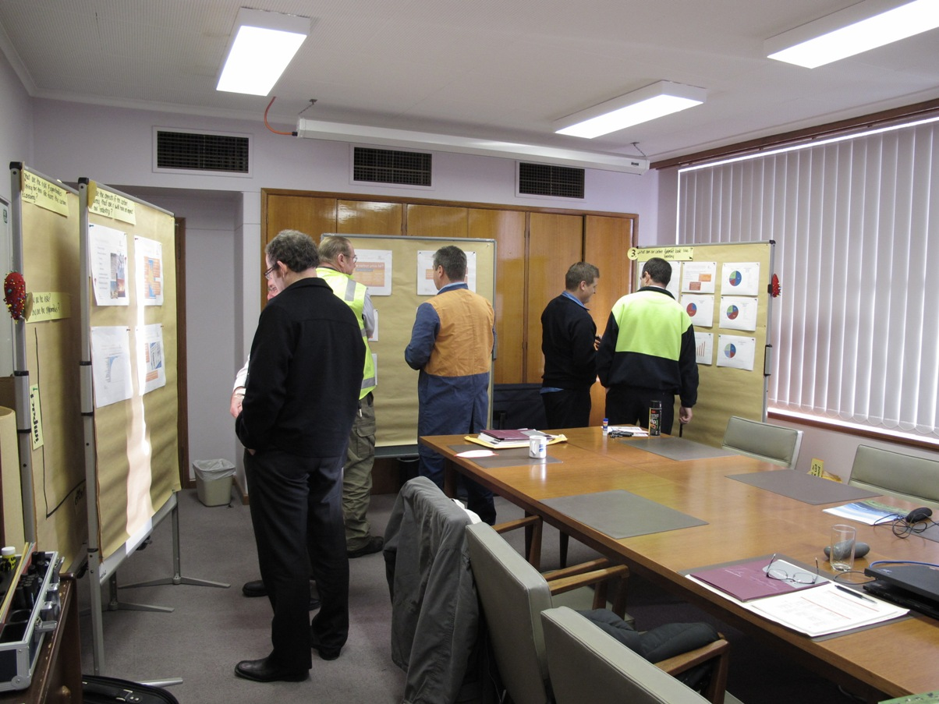 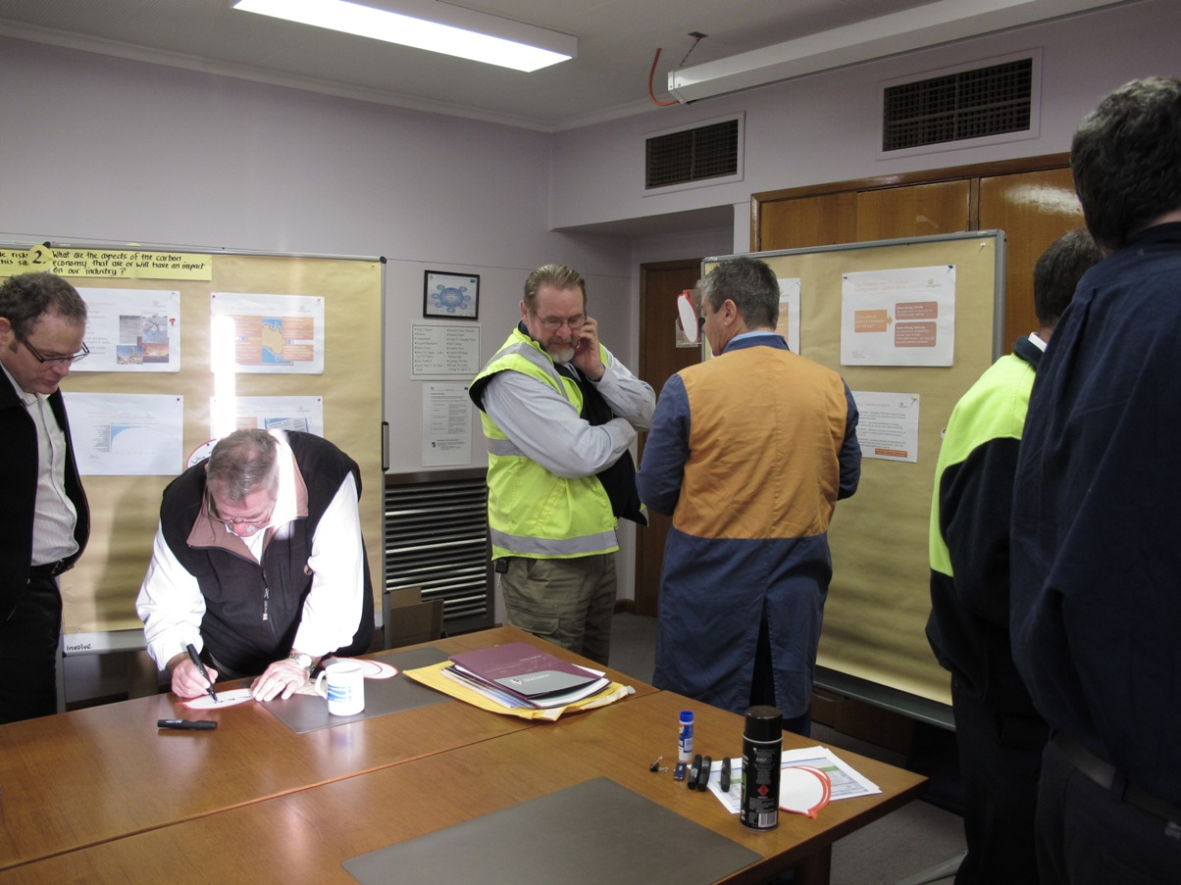

This approach presents information in a meaningful, time efficient and productive manner that promotes engagement and facilitates informed decisions. The features of this methodology make it ideal for senior managers and the planning work performed in each module.