

**Embedding Energy Management (EEM)**

**Practice Guide 4: Energy efficiency opportunities**

|  |
| --- |
| Description: logo_and_text |
| The material provided in this document has been produced in conjunction with our partner [Energetics Pty Ltd](http://www.energetics.com.au/). |

This publication was funded by the Australian Government

through the Workforce Innovation Program under the title 'Carbonproof for Foundries'.

**Embedding Energy Management (EEM) is available from** **www.sustainabilityskills.net.au**

|  |  |
| --- | --- |
|  | **Free for Education Copying**  [www.mskills.com.au](http://www.mskills.com.au) |

This work is copyright and licensed under the MSA Free for Education Copying instant licence (MSA Licence).

When you obtain a copy of material that bears the MSA licence mark by legitimate means you obtain an automatic licence to use and copy the work in whole or in part, solely for educational purposes.

**Individual learners may:**

1. use the material personally for their education such as including it, with proper attribution, in work that is performed in the course of that education; and
2. make unlimited copies, in whole or in part, of the material.

**Education Providers or Other Organisations may:**

1. use the material within the organisation or for the services provided by the organisation;
2. make or give copies to learners;
3. charge for the education provided; and
4. charge learners for the material on a cost-recovery basis.

Queries regarding the MSA Licence conditions should be directed through the MSA website at [www.mskills.com.au](http://www.mskills.com.au)

In addition to the standard MSA Licence conditions, the following **special conditions** apply:

1. Territory: The copyright work must only be used in Australia and New Zealand.
2. Development Rights: Licensees are permitted to develop either an Edited Version or Enhancements of the Licensed Material for individual organisation purposes.

**Disclaimer**

This work is the result of wide consultations with Australian industry participants. It is a collaborative view and does not necessarily represent the view of MSA or any specific body. For the sake of conciseness it may omit factors which could be pertinent in particular cases.

While care has been taken in the preparation of this resource, MSA and the original developer do not warrant that any licensing or registration requirements specified here are either complete or up-to-date for your State or Territory. MSA and the original developer does not accept any liability for any damage or loss (including indirect and consequential loss) incurred by any person as a result of relying on the information contained in this training resource.

This work is in response to the intent of the unit of competency from the respective Training Package but must be customised and contextualised to meet the end user requirements as it may not be fully compliant in its current format. The material is provided on this basis to any person for information and advice for the intended purpose and all persons accessing this material undertake responsibility for assessing the relevance and accuracy of its content. No liability is accepted for any information or services which may appear in any other format. No responsibility is taken for any information or services which may appear on any linked websites.

Published by:

|  |
| --- |
| Manufacturing Skills Australia  Level 3, 104 Mount Street  North Sydney NSW 2060  ABN:88 006 441 685  Phone: (02) 9955 5500  Fax: (02) 9955 8044  Website: <http://www.mskills.com.au>  First published: 2013 |

Contents

[1 Purpose of this guide 1](#_Toc359326795)

[2 Who will benefit from this guide? 2](#_Toc359326796)

[3 Business drivers 2](#_Toc359326797)

[4 Energy efficiency – practices for business 2](#_Toc359326798)

[4.1 Case study 3](#_Toc359326799)

[4.2 Practice steps 6](#_Toc359326800)

[4.3 Supporting tools and templates related to the practice steps 10](#_Toc359326801)

[4.4 Additional websites for reference/general knowledge 11](#_Toc359326802)

# Purpose of this guide

Welcome to the practice guide on energy efficiency.

The opportunity to save 10-30% or more on your utility bills is a common outcome of an energy assessment. Most businesses have had some exposure to energy efficiency, through audit programs, greenhouse gas emissions reporting, government funding schemes, or simply through their own practices and efficient use of resources.

However, the site’s ability to progress the ‘list’ of energy efficiency measures is often hampered by a lack of project ownership by areas of the business, such as maintenance, production, finance and engineering. Frequently there is also a dependency on external consultants to generate this list.

Using this guide, your business leaders can access tools and case study examples to initiate or refresh their list of energy efficiency opportunities so that suitably qualified staff can quantify and prioritise these opportunities as part of the overall energy program for the site. In particular, the team will be better equipped to:

* Present energy and business baseline data that informs the identification of energy efficiency opportunities.
* Identify, prioritiseand align energy efficiency opportunities with overall energy and related business goals.
* Engage others from within teams and across the site to progress energy efficiency opportunities.
* Develop action plans to progress energy efficiency opportunities.
* Revisit action plans and monitor progress against targets.

This practice guide is supported by information and tools in the Embedding Energy Management (EEM) workforce development kit. Relevant tools are highlighted in bold throughout the practice guide. The EEM kit is available from the resources section at [www.sustainabilityskills.net.au](http://www.sustainabilityskills.net.au)**.**

# Who will benefit from this guide?

Site Engineers, Metallurgists, Operations Management, HAZOP and Environment Coordinators, and Energy Champions who have the responsibility for coordinating and facilitating resource efficiency initiatives, and productivity or product-related initiatives that can deliver resource savings. Most businesses have experience with energy audits and are seeking assistance to implement more efficient systems and to improve staff engagement with processes to ensure that cost savings are ongoing.

# Business drivers

The business benefits of developing a systematic response to energy efficiency include:

1. Cost savings
2. Improved productivity
3. Improved security of supply
4. Lower risk of exposure to carbon costs through the supply chain
5. Lower greenhouse gas emissions and subsequent green credentials.

# Energy efficiency – practices for business

This guide presents six key practices that will help business to better understand energy efficiency opportunities and integrate the identification and evaluation of opportunities into their business planning process. These six practices are:

1. Review the need for developing a new list of energy savings opportunities or progressing the existing list
2. Understand and manage energy use
3. Communicate any targets or policies and plans and engage the site about the intent to solicit ideas from management and staff
4. Identify and evaluate energy efficiency opportunities
5. Facilitate implementation of efficiency opportunities by exploiting external funding
6. Measure and verify actual energy efficiencies achieved.

## Case study

Whole-of-business energy asessment leads to $390,000 cost savings at manifold manufacturing site

Inlet manifiold manufacturers X & Co recently installed an energy monitoring system. This system monitors 12 sub-meters on a half-hourly basis at their site in Perth’s CBD and can provide an accurate view of the energy that is being consumed for around 75% of site consumption. Despite installing the system, only one project manager at the site had been reviewing and using the energy consumption data on a daily basis. Prior to the EEM program’s energy efficiency planning forum (Module 4), there had been little or no discussion about this data with other members of the management team despite a number of emails being sent around the business.

The energy efficiency planning forum stimulated discussion and crucially, action. Before conducting the forum the project manager used energy consumption data to develop an energy consumption baseline for the site using the EEM **energy baseline tool.** This shows a breakdown as to which equipment uses the most energy and provides an insight into the areas of great energy savings opportunity.

Using this information, it was possible to walk through the site, identify a number of energy saving opportunities and more easily quantify them by calculating the estimated savings, expected capital cost and simple payback information and tracking this analysis in their EEM **energy efficiency opportunities workbook.**

X & Co has an approximate energy spend of around $1.1 million. The walk-round survey identified energy savings projects which had cumulative individual savings of up to $390,000. This quantification was followed by a workshop where senior staff decided which projects they would like to progress based on business criteria developed in Module 1 of the EEM program. These projects were then prioritised and action plans to progress them drawn up.

Staff at X & Co are currently progressing these opportunities using action plans. When implemented, the sub-metering system will also allow X & Co to measure and verify any expected savings with considerably greater accuracy. You can view their list of opportunities in the X & Co **sample Energy efficiency opportunities workbook** provided in the EEM kit.

**Case example : Energy Efficiency Opportunities** **reporting**

Public reporting of “assessed” energy efficiency opportunities provides another business driver for investing in processes and practices that enable your own team to identify, quantify and prioritise energy efficiency opportunities.

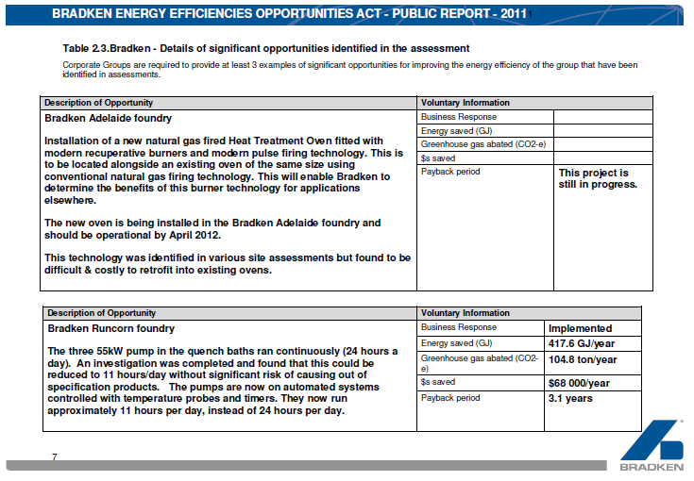

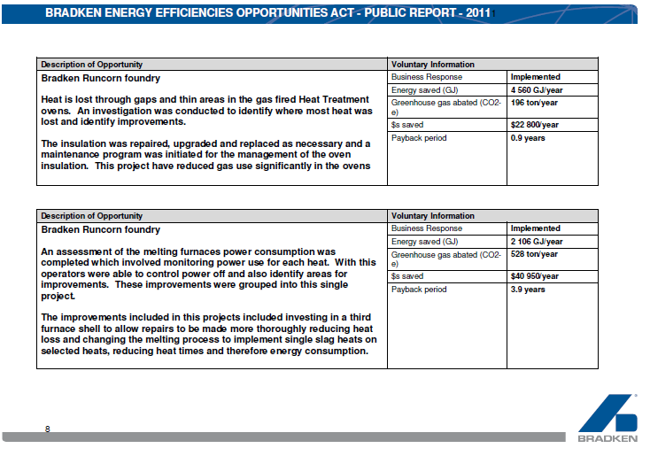

The above case examples are shown here as an example for presentation at exemplar sites. You can see what savings project descriptions might look like and how they can be reported. They are drawn from Bradken’s 2011 Energy Efficiency Opportunities Public Report via [www.ret.gov.au](http://www.ret.gov.au).

## Practice steps

| Practice steps | Description |
| --- | --- |
| 1. **Review the need for developing a new list of energy savings opportunities or progressing the existing list.** | Consider the compliance requirements for conducting energy asessments or audits from state/territory and federal energy regulations that your site might trigger.  Revisit any existing business or energy targets and other business drivers so that the scope is clear and appropriate criteria can be applied when prioritising the opportunities.  Check any existing lists and the currency of the estimated savings, paybacks, and so on, and if satisfied move to Step 4 of this guide.  If a new list is required consider your internal and external resources for generating a new list of energy savings opportunities and move to Step 2. |
| 1. **Understand and manage energy use.** | Develop and use simple utility analysis tools that can aid in understanding resource consumption characteristics and present high-level findings. Simple tools include load profile or interval meter data analysis, monthly or seasonal supply, consumption and cost trend analysis, simple performance indicators, basic regression analysis as well as a break up of consumption data to show where energy is used across the site (energy baseline tool).  Document and retain records, e.g. a data checklist of equipment lists/ratings, performance testing of equipment (e.g. arc furnace maintenance, gas burner checks and motor testing), so that the performance of the most significant energy using equipment is known and is available to support an assessment of improvement opportunities.  Carry out regular metering and monitoring/ instrumentation reviews to ensure that good data on energy use, as well as other parameters (e.g. melt profiles, frequency of motors, compressed air flow, pumped water/fluid flow) is available to support an assessment of improvement opportunities, or to support your carbon footprint analysis. Develop a metering and monitoring plan that supports improvements and compliance.  These tools can be integrated with the **energy baseline tool** for the site so that there is a common reference source for your energy data analysis. |
| 1. **Communicate any targets or policies and plans and engage the site about the intent to solicit ideas from management and staff.** | A list of energy savings opportunities will have value when a range of stakeholders from senior management through to operators contribute their ideas and support the implementation of projects. Planning your communications and organising discussion forums can help ensure that ideas are shared in a timely way and background information distributed as needed. Tools and forums that may be useful to engage with stakeholders to generate such a list include:   * Letter from the CEO or Site Manager outlining the company’s or site’s commitments and targets for energy efficiency. * Use of newsletters to communicate targets, disseminate case studies and solicit improvement ideas. * Establishment of a site ‘Green Team’ to coordinate all energy management and improvement activities, with representatives from all main areas of the site. * Regular communication of energy performance against targets, e.g. on production and other boards that communicate daily, weekly and monthly performance data. * Case studies on opportunities especially from government and industry associations. * Suppliers’ promotional literature and research literature. * Previous examples of savings achieved. |
| 1. **Identify and evaluate energy efficiency opportunities.** | Keep abreast of relevant benchmarking and of leading practices in technology and controls for processes and equipment relevant to your industry. Review their applicability to your operations using a [Best Available Technology](http://eippcb.jrc.es/reference/BREF/sf_bref_0505.pdf) (BAT) checklist or similar. Other strategies to use to compile a list of opportunities include:   * Dedicated forums where the energy baseline and best **BAT** can be discussed and ideas generated by those who are familar with the site and with new technologies or practices. * ‘Walk throughs’ across the site using an audit style checklist. * Energy audits provided by contractors.   Once a list is created, the energy savings, costs and payback periods should be quantified initially using back of the envelope calculations, then a more detailed business case can be developed for higher priority opportunities.  Regularly collate and retain improvement ideas in your **energy efficiency opportunities workbook** or something similar, whether from suggestion boxes, toolbox talks, past workshops, audits, the BAT checklist or industry literature.  A useful way to initiate an annual planning process is to hold a dedicated energy efficiency opportunities workshop with stakeholders, bringing together relevant information from your business plans, and analysis of energy information and data, together with benchmarking data and technology practices. The purpose of such a workshop is to elicit ideas for improvement from a broad group, and to prioritise these based on business case evaluation criteria informed by your energy planning process (refer toModule 1 of this program).  To support ideas arising from a workshop or other opportunities identification process, project briefs or action plans to build the required business case should be developed. These should:   * Include responsibilities, accountabilities and deadlines for completing any further evaluations, e.g. based on monitoring, engineering calculations, trials and receipt of quotes from suppliers. * Apply business criteria for efficiency opportunities evaluations. For example, identify possible co-benefits, such as improved work health and safety (WHS) outcomes, better supply security, enhanced productivity, reduced maintenance, and possible risk issues, such as interruption to production, adverse WHS or environmental outcomes. * Reach a recommended course of action whether to proceed or not, and present to site management for approval, e.g. as a draft energy improvement plan to be progressed via your usual continuous improvement and management teams. |
| 1. **Facilitate implementation of efficiency opportunities by exploiting external funding.** | Understanding potential funding incentives that can make marginal projects more cost-effective for your business. At any one time there are likely to be a range of incentives that you could access to help fund efficiency improvements. These may be from the federal, state/territory or local governments. Keeping up to date with available funding opportunities through industry links and proactive engagement with funding agencies, will ensure that your business does not miss out on funding that can help you make significant energy cost savings.  Understanding the potential co-benefits for energy efficiency opportunities can further improve project cash flows. For example:   * Your efficiency projects may be eligible to create credits under a state efficiency scheme (eg. the NSW Energy Savings Scheme), or under the proposed National Energy Savings Initiative (NESI). * Your project may be eligible for funding assistance through one or more of the measures in the Clean Energy Future package, or through Low Carbon Australia. * Your projects may lower your electricity demand, which may benefit your network provider who may be willing to provide you with an incentive. |
| 1. **Measure and verify actual energy efficiencies achieved.** | Regular performance reporting against targets can ensure that management is routinely informed of progress, and can act to increase, change or reward effort depending on what is being achieved.  Some larger projects may warrant project level measurement and verification. This can serve multiple purposes; it demonstrates to your business if savings have been achieved, which can influence future investments or roll-out of opportunities; or it may be needed to support claims for co-benefits or credits. |

## Supporting tools and templates related to the practice steps

The EEM tools are available from [www.sustainabilityskills.net.au](http://www.sustainabilityskills.net.au)

| Tool or template | This tool is useful if... |
| --- | --- |
| **Energy efficiency opportunities workbook** | You have a range of efficiency, metering or management system improvement ideas, and you want to have a central location to record the ideas, the analysis of costs and savings, and implementation recommendations.  You are develoing an energy improvement project register and want to prioritise projects. |
| **Energy baseline tool** | You are building on high-level analysis of energy, water and carbon data to analyse more data that will inform the identification and evaluation of improvement opportunities. |
| **Energy efficiency opportunities facilitator runsheet**  **Energy efficiency opportunities presentation guide**  **Sample energy efficiency opportunities workbooks** | You want to run the energy efficiency opportunities planning forum.  You have a range of stakeholders who can contribute to the identification and evaluation of energy improvement opportunities, and you want to evaluate these opportunities so that an improvement plan can be prepared.  You have forums for engagement of staff, such as toolbox talks, suggestion boxes, web/intranet forums, and you want to use these to solicit energy improvement ideas.  You have identified energy improvement opportunities and want the evaluation of these to be carried out consistently by nominated responsible staff. |

## Additional websites for reference/general knowledge

The following websites are recommended for background knowledge and further reference.

| Website link | This website is useful because… |
| --- | --- |
| **Energy Excellence (Department of Resources Energy and Tourism)**  <http://eex.gov.au/> | This site provides links to a wide range of best practice websites that have been independently evaluated. |
| **Australian Foundries Institute (AFI)**  [http://afiaustralia.org](http://afiaustralia.org/?page_id=726) | The Foundry Industry Energy Efficiency (FIEE) Toolkit aims to provide decision-makers of SME foundry businesses with the guidance, tools and links to support to both assess their potential for energy efficiency improvements, and gather enough evidence to make an informed decision around investing in these improvements, or undertake further business case assessment. |
| **Standards Australia – Auditing standards**  <http://www.saiglobal.com/PDFTemp/Previews/OSH/as/as3000/3500/3598.pdf> | The Australian Standard for energy auditing forms the basis for most energy efficiency schemes over the past 20 years (AS/NZS 3598:2000). This standard is due to be upgraded in the near future. |
| **International Standards Organisation (ISO)**  <http://www.iso.org/iso/iso_catalogue.htm> | The ISO has developed an international energy auditing standard. |

| Website link | This website is useful because… |
| --- | --- |
| **Federal and state/territory governments water and energy efficiency programs** | These websites provide frameworks for government-designed energy and water efficiency programs. Although participation is mandatory for companies triggering energy or water consumption thresholds, the framework and documented guidance for engaging with these programs can still be adopted by non-triggering organisations who are keen to embed water and energy efficiency into their daily operations.  EEO: <http://www.ret.gov.au/energy/efficiency/eeo/pages/default.aspx>  ESAP: <http://www.environment.nsw.gov.au/sustainbus/savingsactionplans.htm>  EREP: <http://www.epa.vic.gov.au/bus/erep/>  QLD SESP: <http://www.cleanenergy.qld.gov.au/smart_energy_savings_program.cfm>  WSAP: <http://www.waterforlife.nsw.gov.au/waterefficiency/businesses/water_savings_actions_plans>  WaterMap: <http://www.ourwater.vic.gov.au/saving/industry/watermap> |
| **Measurement and verification**  <http://www.lbl.gov/> | The Lawrence Berkeley National Laboratories in the US developed the international standards on measurement and verification (the Measurement and Verification Protocol or MVP). |
| **NSW Energy Savings Scheme**  <http://www.ess.nsw.gov.au/Home> | NSW energy retailers have obligations to reduce energy use in NSW to 2014, and they are required to surrender certificates equating to energy savings in proportion to their market share. Savings are delivered by efficiency actions implemented by end users: businesses and householders. Details of the Energy Svaings Scheme and requirements for verification of energy savings are on the scheme website. |
| **Lean manufacturing**  <http://www.leanmanufacturingguide.com/> | Continuous improvement approaches for energy efficiency can be similar to those employed in lean manufacturing, or other improvement process such as 6-sigma. |
| **Best Available Techniques Reference (BREF) document for Smitheries and Foundries, May 2005**  **(European Integrated Pollution Prevention and Control Bureau)**  <http://eippcb.jrc.es/reference/BREF/sf_bref_0505.pdf> | It contains a comprehensive review of best available techniques, including technologies and operating practices through the lifecycle of technology through to decommissioning, for the foundries and smitheries industries, covering all ferrous and non-ferrous processes commonly used in industry. It also covers emerging technologies and contains a range of useful energy-related benchmarking information. |
| **Guide to Energy Efficiency Opportunities in Canadian Foundries**  <http://oee.nrcan.gc.ca/industrial/cipec/newscentre/foundry/10950> | A practice guide for energy efficiency in the Canadian foundry industry which may be a useful resource when considering processes for developing an energy efficiency response, industry energy benchmarks and efficiency improvement opportunities. |