**Embedding Energy Management**

**Practice Guide – Module 5: Energy management systems**

|  |  |
| --- | --- |
| The material provided in this guide has been produced in conjunction with our partner Energetics Pty Ltd. | Description: logo_and_text |

This publication was funded by the Australian Government

through the Workforce Innovation Program under the title 'Carbonproof for Foundries'.

**Embedding Energy Management is available from** **www.sustainabilityskills.net.au**

|  |  |
| --- | --- |
|  | **Free for Education Copying**  [www.mskills.com.au](http://www.mskills.com.au) |

This work is copyright and licensed under the MSA Free for Education Copying instant licence (MSA Licence).

When you obtain a copy of material that bears the MSA licence mark by legitimate means you obtain an automatic licence to use and copy the work in whole or in part, solely for educational purposes.

**Individual learners may:**

1. use the material personally for their education such as including it, with proper attribution, in work that is performed in the course of that education; and
2. make unlimited copies, in whole or in part, of the material.

**Education Providers or Other Organisations may:**

1. use the material within the organisation or for the services provided by the organisation;
2. make or give copies to learners;
3. charge for the education provided; and
4. charge learners for the material on a cost-recovery basis.

Queries regarding the MSA Licence conditions should be directed through the MSA website at [www.mskills.com.au](http://www.mskills.com.au)

In addition to the standard MSA Licence conditions, the following **special conditions** apply:

1. Territory: The copyright work must only be used in Australia and New Zealand.
2. Development Rights: Licensees are permitted to develop either an Edited Version or Enhancements of the Licensed Material for individual organisation purposes.

**Disclaimer**

This work is the result of wide consultations with Australian industry participants. It is a collaborative view and does not necessarily represent the view of MSA or any specific body. For the sake of conciseness it may omit factors which could be pertinent in particular cases.

While care has been taken in the preparation of this resource, MSA and the original developer do not warrant that any licensing or registration requirements specified here are either complete or up-to-date for your State or Territory. MSA and the original developer does not accept any liability for any damage or loss (including indirect and consequential loss) incurred by any person as a result of relying on the information contained in this training resource.

This work is in response to the intent of the unit of competency from the respective Training Package but must be customised and contextualised to meet the end user requirements as it may not be fully compliant in its current format. The material is provided on this basis to any person for information and advice for the intended purpose and all persons accessing this material undertake responsibility for assessing the relevance and accuracy of its content. No liability is accepted for any information or services which may appear in any other format. No responsibility is taken for any information or services which may appear on any linked websites.

Published by:

|  |
| --- |
| Manufacturing Skills Australia  Level 3, 104 Mount Street  North Sydney NSW 2060  ABN:88 006 441 685  Phone: (02) 9955 5500  Fax: (02) 9955 8044  Website: <http://www.mskills.com.au>  First published: 2013 |

Contents

[1 Purpose of this guide 1](#_Toc359328329)

[2 Who will benefit from this guide? 2](#_Toc359328330)

[3 Business drivers 2](#_Toc359328331)

[4 Energy management systems– practices for business 2](#_Toc359328332)

[4.1 Case study - Ronson Torsion Bars 4](#_Toc359328333)

[4.2 Practice steps 10](#_Toc359328334)

[4.3 Supporting tools and templates related to the practice steps 13](#_Toc359328335)

[4.4 Additional websites for reference/general knowledge 14](#_Toc359328336)

# Purpose of this guide

Welcome to the practice guide outlining ways to enhance your energy management systems, processes and practices.

Having developed an energy plan, an energy program and a list of prioritised energy cost-saving initiatives, your business needs to be able to realise and maintain the cost savings on offer. Energy should be integrated into existing management systems in line with what you have discovered from the previous Modules in this program (Modules 1-4).

This approach will ensure that energy efficiency is factored into business decisions on an ongoing basis. Your business can also demonstrate to existing and potential customers the resource and carbon footprints of your organisation, as well as produce auditable figures to meet reporting requirements. The relevant management systems include:

* policies and management reporting
* employee roles and responsibilities
* standard operating procedures
* energy assessment and continous improvement processes
* capital expenditure documentation
* resource-use reporting.

This practice guide is supported by information and tools in the Embedding Energy Management (EEM) workforce development kit. Relevant tools are highlighted in bold throughout the practice guide.

The EEM kit is available from the resources section at [www.sustainabilityskills.net.au](http://www.sustainabilityskills.net.au).

# Who will benefit from this guide?

This guide is intended for the use of General Managers, Finance and Procurement and Supply Chain Managers. However, Site Engineers, Energy Champions and others who have the desire to learn more about systemic change that delivers ongoing cost savings and sustainability benefits would also find this guide valuable.

# Business drivers

Evidence shows that strong management systems which underpin actions to reduce a business’ environmental impact result in greater savings that can be sustained over the longer term. Savings actions implemented in the absence of strong management systems can often be lost, as the business shifts its focus to other priorities.

The key benefits of investing in energy management systems include:

* Implementation of your strategic response to global and regional trends in pricing and supply.
* Meeting the demands of your customers who require insight into the carbon and energy footprints of your business.
* A greater likelihood that energy efficiency opportunities will be implemented and savings sustained over longer time periods.
* Better use of energy performance data to inform investment decisions.

# Energy management systems– practices for business

This guide presents six key practices to help business better understand the importance of management systems for energy and how they can drive continuous improvement. These six practices are:

1. Facilitate an understanding amongst the management team, of a systems approach to energy efficiency in support of the energy plan or program.
2. Diagnose and investigate gaps in systems with the management team.
3. Design improvements to management systems.
4. Implement improvements to management systems.
5. Benchmark your energy management system using energy management (ISO 50001) or other quality management systems, such as ISO 9000 or 14000.
6. Monitor, investigate and report outcomes of enhancements to management systems.

While an energy management program is often a stand-alone undertaking, it benefits from the synergistic support of other company management systems, which share a common philosophy. Quality or environmental management systems, such as those based on ISO 9000 (QMS) and ISO 14001 (EMS), introduce order and limit chaos – the daily ‘firefighting’ of recurring problems or the roller coaster of short-term savings followed by longer periods of energy waste.

Energy consumption is among the most significant environmental aspects of any foundry or fabrication business so the energy management program is especially suitable for integration with environmental management systems. Under ISO 14001, a business must manage its significant aspects in a number of ways. One way is setting objectives and targets from which environmental management programs (i.e. action plans) are developed.

Reduction of energy consumption is a common objective, achievable through environmental (in this case, energy) management programs. ISO 14001 emphasises continual improvement (as does the new ISO 9000:2000) and strengthens this integration. It gives the energy management program, which becomes part of an overall environmental effort, the regular attention and review by top management.

It is also significant that that a vast majority of the 30,000 companies registered to ISO 14001 around the world (spring 2001) cited internal cost benefits as a major reason for implementation of an energy management system.

## Case study - Ronson Torsion Bars

Ronson Torsion Bars decided to build a responsive energy management system to support the $300,000 of enery savings on offer at their site in Western Sydney. The management team at Ronson, Western Sydney completed an energy management systems diagnostic as part of their energy management system planning forum (Module 5 of the EEM program).

After the diagnostic, the team discussed what the recommendations meant for their site, resulting in agreed actions and responsibilities for making sure the $300,000 worth of savings on offer is managed by improving the sites energy management system.

The diagnostic elements are outlined below, including diagnostic result (star rating for overall system as well as elements of the system)and recommended actions.The process here is detailed in the practice steps on page 10 and the M5 facilitators runsheet that forms part of this kit.

**Diagnostic results**

The results indicated an overall star rating of 1 Star, evaluatingRonson as having ‘limited focus on energy’. A 5% improvement is required to reach 2 stars which would bring the site level with the industry average.

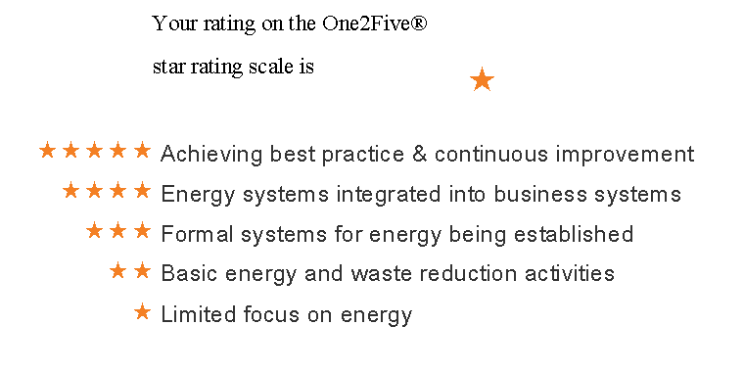

Figure 1: Overall star rating from Ronson’s One2Five diagnostic

However, each element is assessed individually to identify areas most critical for improvement. This is outlined in detail in Figure 2.

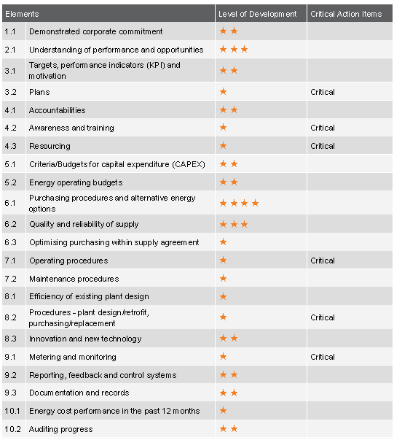

Figure 2: Assessment of each element

The team discussed these results and agreed that 2 stars would be the improvement target for 2013 and 3 stars for 2014, especially if energy prices continue to rise at a similar rate.

**Action plan**

Based on the critical actions identified by the diagnostic, the management team at Ronson developed action plans for improved energy performance and integration into existing business processes. The actions are allocated to a person with responsibility for implementation and a date is set when implementation should be complete.

An extract from the Ronson management systems disganostic action plan is outlined in Figure 3 below. See the full action plan in diagnostic sample report.

|  |
| --- |
| Awareness and training system |
| Recommendation from diagnostic tool: Conduct activities to raise awareness of basic energy issues, focusing on cost savings and environmental impacts. Broadcast  information using tools, such as newsletters. |
| Tenneco Inc comments:  1) Add sustainability metrics inc energy into main EH&S BOS board  2) Include sustainability (including energy) in the monthly plant communications meetings  3) Generate a quarterly sustainability newsletter, including energy  4) Access training for combustion analysis and burner tuning  work with AGL technicians and training provider to coach on the job  5) Take the keypoints from new energy contracts and make relevant data available to key production staff so that they can maintain peak load agreements etc |
| Responsible Manager Gary Smith. Implementation expected by 1/07/2013 |

Figure 3: Extract from Ronson management system action plan

**Benchmarking**

In addition to developing action plans, results were benchmarked against similar sites surveyed. Further discussion by the management team led to the decision to include energy management practices in the site’s quality manangement audit conducted each year and to ‘re-diagnose’ the energy aspects of the system in six months time so that the expected improvement could be monitored and corrective or additional actions identified. The overall energy performance of the site would be reviewed at the same time using the **EEM energy baseline tool** and the product to energy key performance indicators (KPIs) that are also under development.

Figure 4 depicts the benchmarking outcomes. The benchmarking summary compares a site’s performance against industry sector, country and all sites. The company benchmarked’s score is presented by the green bar on the left hand side of the figure below.This result further motivates the team to improve the system and to repeat the benchmarking in six months to recognise progress towards best practice in the sector.

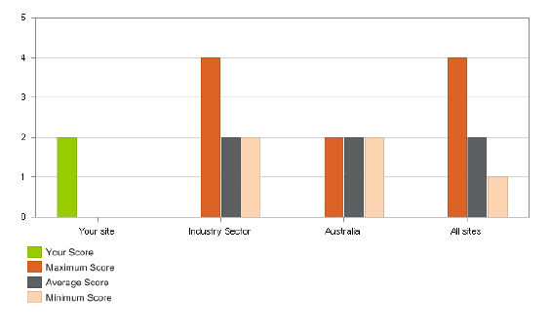

Figure 4: Benchmarking results

**Project briefs**

For each of the actions identified in the diagnostics action plan, a project brief was developed in a collaborative manner to achieve implementation. The collaborative approach is critical to foster the cooperation needed across the management team to progress projects that sit outside of their core roles and responsibilities. An example of a project brief for one of the recommended critical actions in the diagnostic report is outlined in the table below.

|  |  |
| --- | --- |
| **Project question or description** | **How to engage all team members in energy efficiency** |
| Purpose of this project | To improve the staffs awareness of the ned and potential for saving costs so that they initiate cost saving actions rather than waiting to be told what to do. This could provide ideas for large savings as well as maintaining savings and making incremental improvements |
| What information – Current status? | There is a reactive culture, e.g. air leaks are not getting fixed |
| Other questions to be resolved | What Iimmediate actions can be undertaken to save money?  What is the number or incidence of ideas implemented?  What informal chat about energy efficiency can we promote?  What measures are included in job descriptions, KPIs, PR, etc..?. |
| Who else will contribute? | Management team and communications/HR - Karen |
| Which system will be affected or enhanced to used to progress the project? | Continuous improvement, communications, training and work health and safety (WHS) |
| Where is history filed? | BOS operations and improvment system |
| Project owner | Gary |
| Business unit or system most affected | Communications will need to gather and present energy perfoemence data and efficiency stories top tips  Training will need to include a new toolbox session  HR performance reviews will need to be changed to reflect the requirement for energy savings ideas  Maintenence will need to support sub-metering |
| Savings estimates | 5% energy usage year on year as estimated in case examples from other sites |
| Date when benefits will be realised | Survey every 6 months for 18 months  Review using diagnostic tool |
| Design brief to control quality/outcomes/next phase | 1. We should survey now and survey in 6 months so that we can monitor the level of energy efficiency awareness. Action: 2. We should design toolbox session for energy efficiency so that we improve awareness and integrate practices -SOPs 3. We should add an energy efficiency story to our newsletters so that staff know that it is important to the business 4. We should provide energy performance – data displays so that staff can see the impacts of their energy waste efforts 5. We should communicate top tips for the month (including tips for saving energy at home and work) so that staff can try out improvements with confidence |
| First activities to progress this brief | Activity - Who /with - by when   1. Upload energy data from existing sub-meters to screens - Ron/Arthur - by 30 April 2. Send survey to Ron to customise - Phil and RS - by 20 November 3. Prepare the toolbox session - Ron / Phil - by 30 May 4. Brief Karen on newsletter stories so far bi-monthly 5. Request a one page outline from AGL for training operators on burner tuning - Arthur with Ron - by 30 May |

## Practice steps

| Practice steps | Description |
| --- | --- |
| **Facilitate an understanding amongst the management team of a systems approach to energy efficiency in support of the energy plan or program** | Present the site’s energy plan to senior management and include a range of inputs from your investigations and engagement with stakeholders, including:   * Global trends and how these impact your business and your strategic response so far * Targets or other drivers for energy/carbon abatement * Your carbon inventory, reporting needs, supply chain impacts and associated action plans * A range of cost-saving opportunities available to your business * Identified risks and plans for management to enable progress * The theory of a systems approach to energy management (refer to presentation)   These outputs require management support and management systems integration (or improvement) if the benefits are to be realised and sustained. Good practice will see plans that are incorporated into the overall business plan and budget process, supported by the leadership team, with roles and responsibilities defined, timelines agreed and monitoring and reporting metrics established. |
| **Diagnose and investigate gaps in systems with the management team** | An effective energy management system will consider a range of business functions, including:   * Leadership * Investigation of opportunities and planning * People development – awareness, accountabilities and responsibilities * Budgets and purchasing procedures/guidelines * Energy supply purchasing * Operations and maintenance of plant and equipment * Innovation and technology selection for new plant and processes * Metering, monitoring, auditing and reporting of outcomes   Facilitate an evaluation by the site leadership team (SLT) of management systems for energy, water and carbon, using a structured approach. A range of simple web-based multiple-choice question style diagnostic tools can assist. A BRESCU matrix is also available or the ISO 50000 standards could also be used as form of checklist/diagnostic. Alternatively use Energetics One2Five diagnostic.  The output from this session is a list of key priority areas to improve management systems, with an agreed action plan.  An added value aspect of benchmarking tools is the ability to benchmark your management system’s performance against others in your sector, which can influence the aims and extent of your improvement goals. |
| **Design improvements to management systems** | Your assessment of management systems and of energy efficiency improvements may highlight a range of improvements that can help to improve understanding of resource use and create interest in seeing performance trends over time. This will be aided by improvements, such as:   * Development of energy and carbon KPIs, for example, for major production units (e.g. furnaces) and/or auxiliary services (e.g. compressed air) * Development of a metering and monitoring plan that will provide useful information on key areas or services that can drive improvement efforts * Development of a metering and monitoring capability for resource use in the product lifecycle * Establishment of the capacity for reporting of energy and carbon performance to inform business plans |
| **Facilitate implementation of improvements to management systems** | Present required changes and facilitate the creation of improvement briefs for each system. Work with system owners using a facilitated forum to get understanding about the system and the commitment and cooperation required to achieve the goals.  Changes to site management systems (e.g. planning, production, procurement, maintenance, supply chain management, quality assurance and business improvement) are best made by system owners with input from the SLT as needed. Continuity of focus and maintaining the relevance of plans through regular review and renewal is essential to your carbon and energy improvement efforts.  With inclusion in regular meetings, the team can track resource use against targets and review the status and effectiveness of agreed improvements to the energy system.  A key aspect of an improvement process is usually to establish roles and accountabilities for energy management. Typically this may entail updating job descriptions for employees and contracts for contractors based on EEM plans. |
| **Benchmark your energy management system using energy management (ISO 50000) or other quality management systems, such as ISO 9000 or 14000** | Engage your site’s quality system to benchmark the performance of your stystem and to regularly review the performance of the system. Consider referencing international standards, such as ISO 9000, 14000 or 50000, depending on what already exists at the site, customer and compliance requirements, and other business drivers. |
| **Monitor, investigate and report outcomes of enhancements to management systems** | Administer follow-up reviews of management systems using diagnostics or another approach. Benchmark performance in the industry where possible. Update plans periodically to reflect new or changed focus resulting from these reviews. This should be done at least annually in line with a review of overall energy plans, but may be done more frequently as management focus and priorities change. |

## Supporting tools and templates related to the practice steps

The EEM tools are available from [www.sustainabilityskills.net.au](http://www.sustainabilityskills.net.au)

| Tool or template | | This tool is useful if… |
| --- | --- | --- |
| **BRECSU Matrix Energy**  One2Five®online system (Energetics, fees apply) [www.one2five.com](http://www.one2five.com) | You want to systemise your response to resource efficiency management based on compliance or business drivers.  You want to engage the SLT in deciding priorities and taking ownership to enhance their management systems using a ‘diagnostic’ tool.  You want to benchmark your practices compared to ‘like’ companies to better understand gaps and establish motivating factors. |
| **Sample management improvements – Perth Mint**  (KPIs and targets) | You are seeking to integrate resource efficiency measures into business reporting.  You need accountability in quantitative terms so the business can benchmark resource and production performance.  You want people to be motivated to initiate and/or implement efficiency opportunities. |
| **Sample management improvements – Torsion bars**  (Metering and reporting) | You are developing metering plans that will capture and allow reporting for key systems so improvement opportunities can be identified and evaluated. |
| **Sample management improvements - Bradken**  (People accountabilities) | You have targets in place and relevant policies which should be reflected in adjustments to job descriptions so that appropriate staff are accountable for outcomes and motivated or incentivised to achieve goals. |

## Additional websites for reference/general knowledge

The following websites are recommended for background knowledge and further reference.

| Website link | This website is useful because… | |
| --- | --- | --- |
| One2Five®online system  (Energetics, fees apply)  [www.one2five.com](http://www.one2five.com) | A range of management diagnostics are available to support improvement to energy, water or carbon.  This is one example of a suite of tools that can assist with the diagnosis of performance, benchmarking and setting of management priorities. |
| NSW DECCW Sustainability Advantage program  [www.environment.nsw.gov.au/sustainbus/sustainabilityadvantage.htm](http://www.environment.nsw.gov.au/sustainbus/sustainabilityadvantage.htm) | Sustainability Advantage is a business support service from the NSW Office of Environment and Heritage that can help organisations to improve their environmental performance by helping them to plan, implement and monitor improvements. |